School Name
Mathematics Test 2017
Year 10 |  | Simultaneous Equations | Non Calculator
Skills and Knowledge Assessed:  - Solve linear simultaneous equations, using algebraic and graphical techniques including using digital technology (ACMNA237) |  |  | Name_________________
Section 1 Short Answer Section
Write all working and answers in the spaces provided on this test paper.

Find the point of intersection of the lines 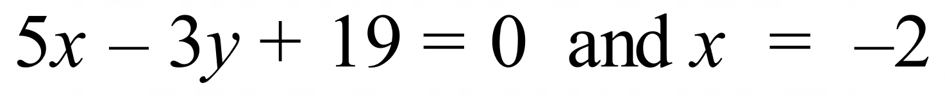 without drawing a graph.

……………………………………………………………………………………………....

……………………………………………………………………………………………....

……………………………………………………………………………………………….
Solve simultaneously:

……………………………………………………………………………………………....

……………………………………………………………………………………………....

……………………………………………………………………………………………....

……………………………………………………………………………………………….
What is the x value of the point of intersection of

..........................................................................................................................................................

..........................................................................................................................................................

..........................................................................................................................................................

..........................................................................................................................................................
Solve the simultaneous equations:

..........................................................................................................................................................

..........................................................................................................................................................

..........................................................................................................................................................
..........................................................................................................................................................
Find the values of u and v for which

..........................................................................................................................................................

..........................................................................................................................................................

..........................................................................................................................................................

..........................................................................................................................................................

..........................................................................................................................................................
Find the point of intersection of

..........................................................................................................................................................

..........................................................................................................................................................

..........................................................................................................................................................

..........................................................................................................................................................
 | 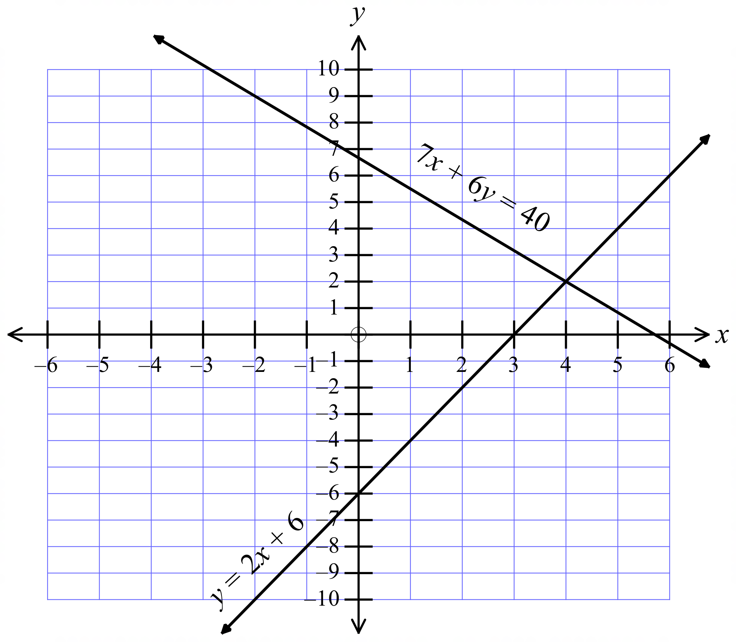Questions 7 – 12 refer to the graph below which shows the lines 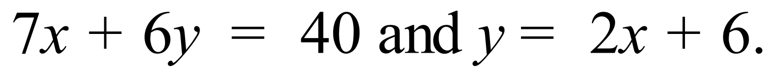 .
Solve simultaneously: 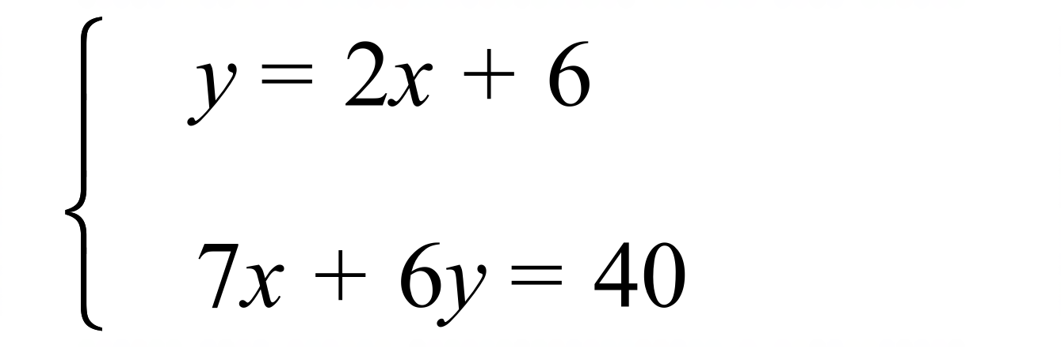
..........................................................................................................................................................
 | Sketch 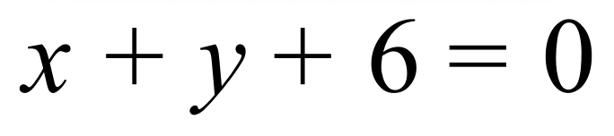 on the graph above
 | Sketch 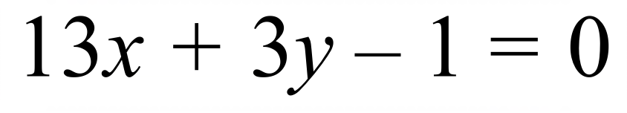 on the graph above.
Solve simultaneously: 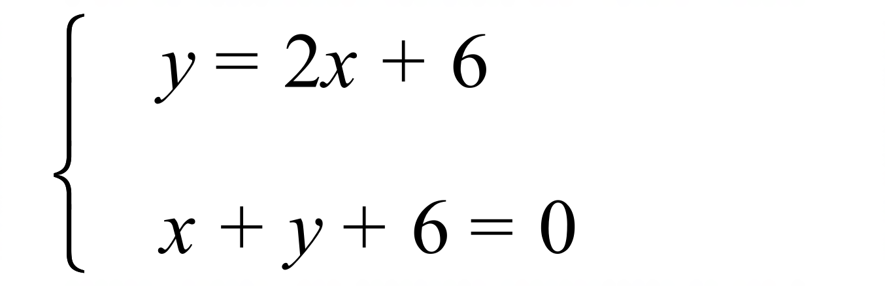
..........................................................................................................................................................
Solve simultaneously: 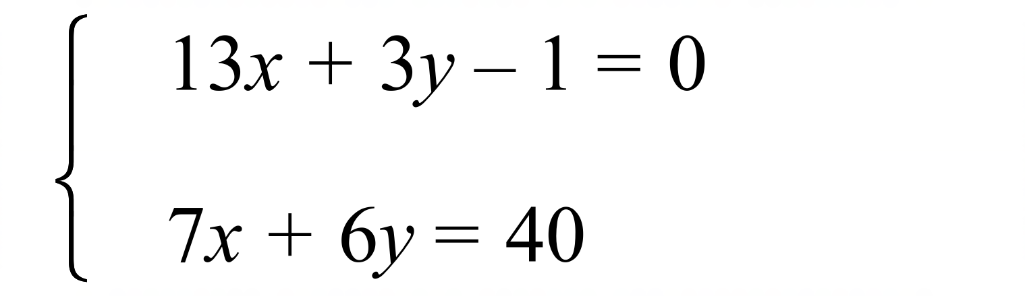
..........................................................................................................................................................
Estimate the simultaneous solution to: 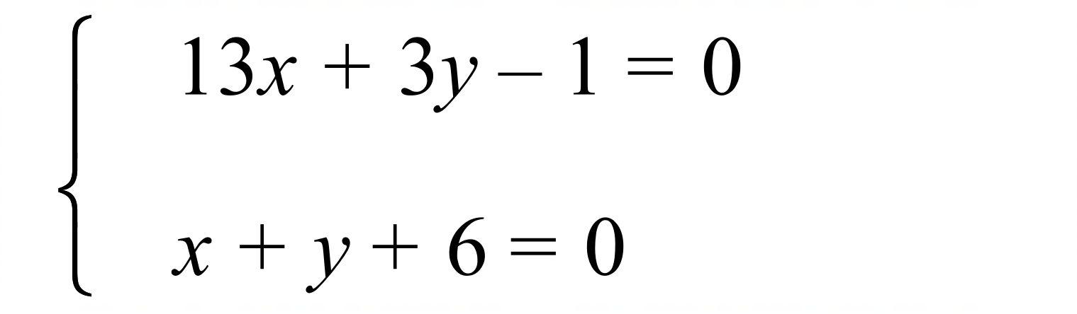
..........................................................................................................................................................

School Name
Mathematics Test 2017
Year 10 |  | Simultaneous Equations | Calculator Allowed
 |  | Simultaneous Equations | Name_________________
Section 2 Multiple Choice Section
Mark all your answers on the accompanying multiple choice answer sheet, not on this test paper. You may do any working out on this test paper. Calculators are allowed for this section.

Solve simultaneously 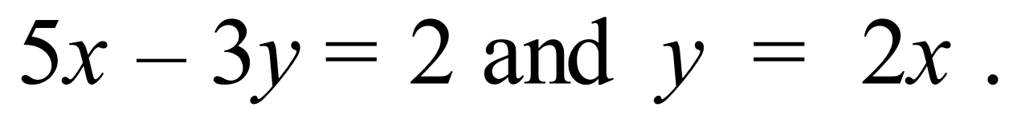

A. 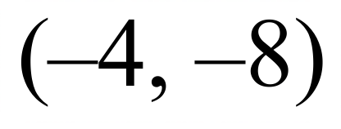 B. 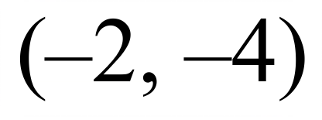 C. 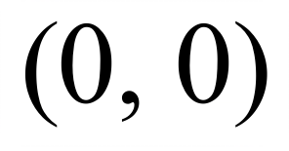 D. 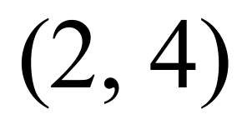
Tim intends to solve the simultaneous equations below, using the substitution method.
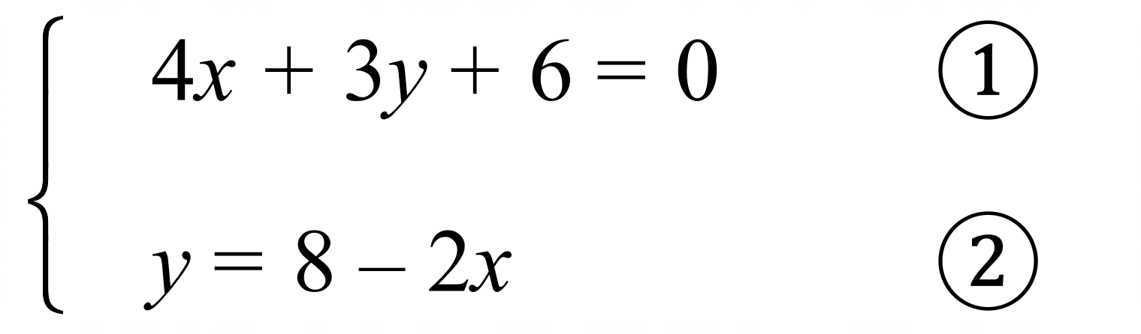
Which line would follow?
A.
B.
C.
D.
Questions 3 and 4 refer to the following:
A partially completed solution to a pair of simultaneous equations is shown:
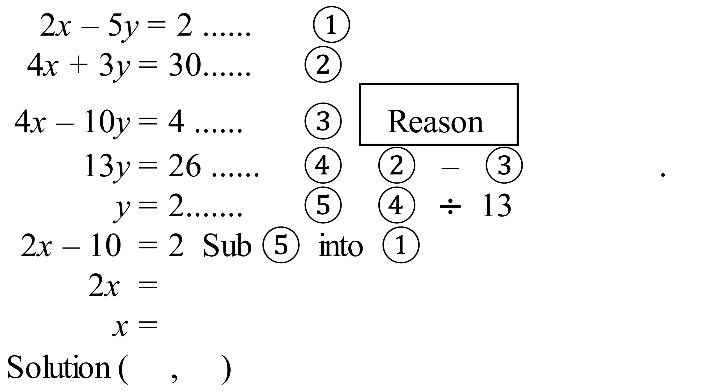
What is the missing reason which should be given for equation 

A. 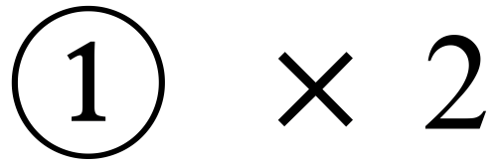 B.  C.  D. 
What is the final solution to the simultaneous equations?

A. 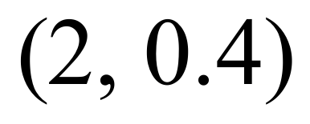 B. 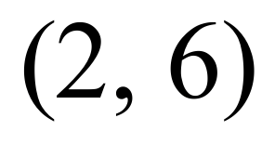 C. 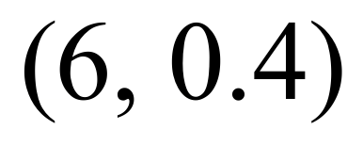 D. 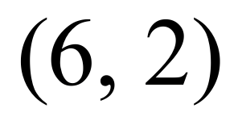
What ordered pair is a solution to the simultaneous equations below?
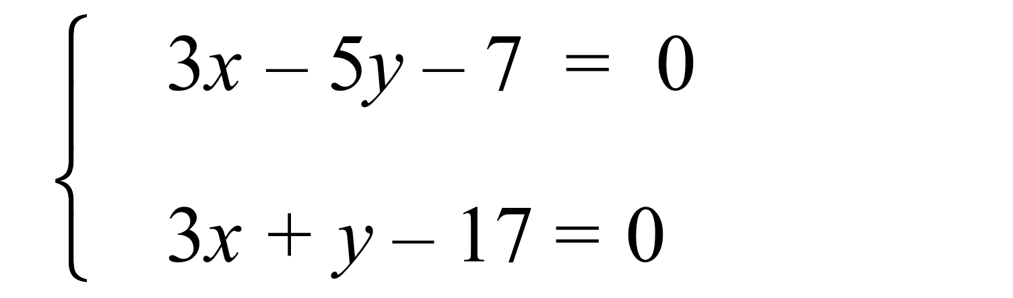

A. 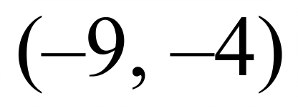 B. 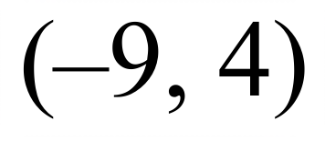 C. 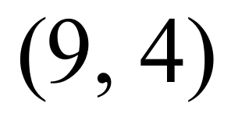 D. 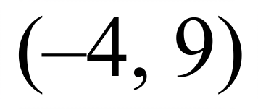
What is the value of a when the equations below are solved simultaneously?
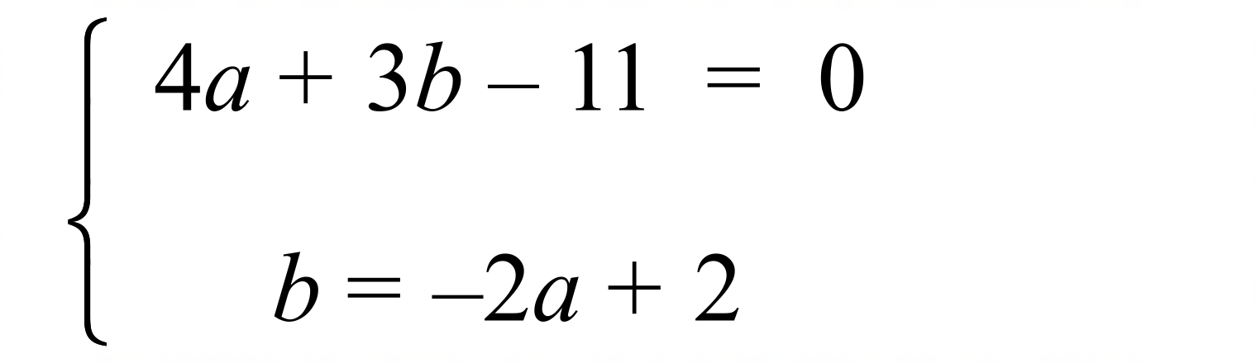

A. 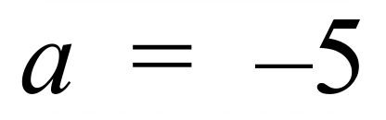 B. 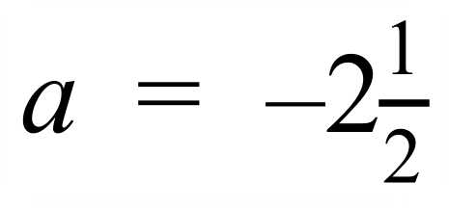 C. 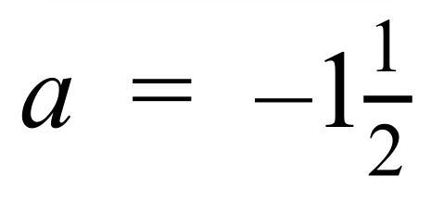 D. 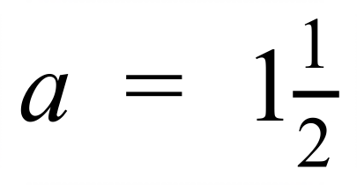
What is the x value, when the equations below are solved simultaneously?
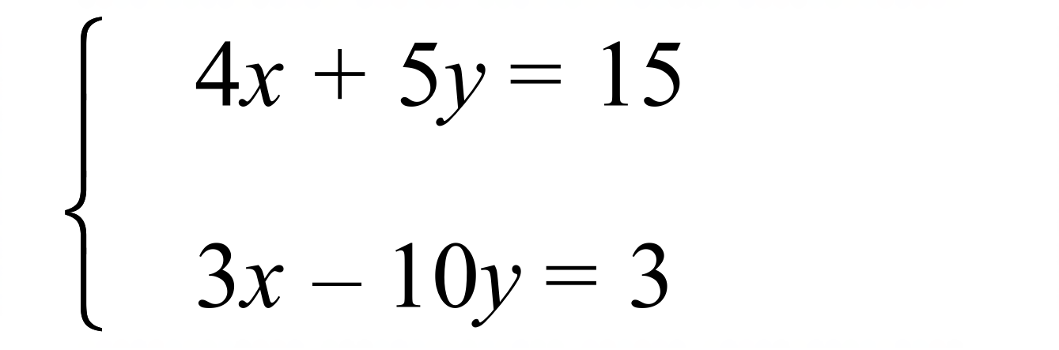
A. 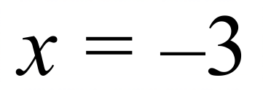

B. 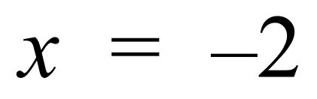

C. 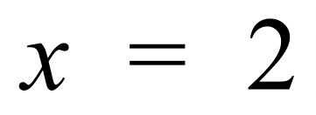

D. 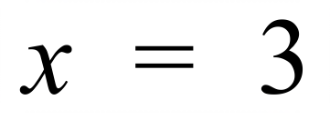

Question 8 – 9 refer to the graph below.
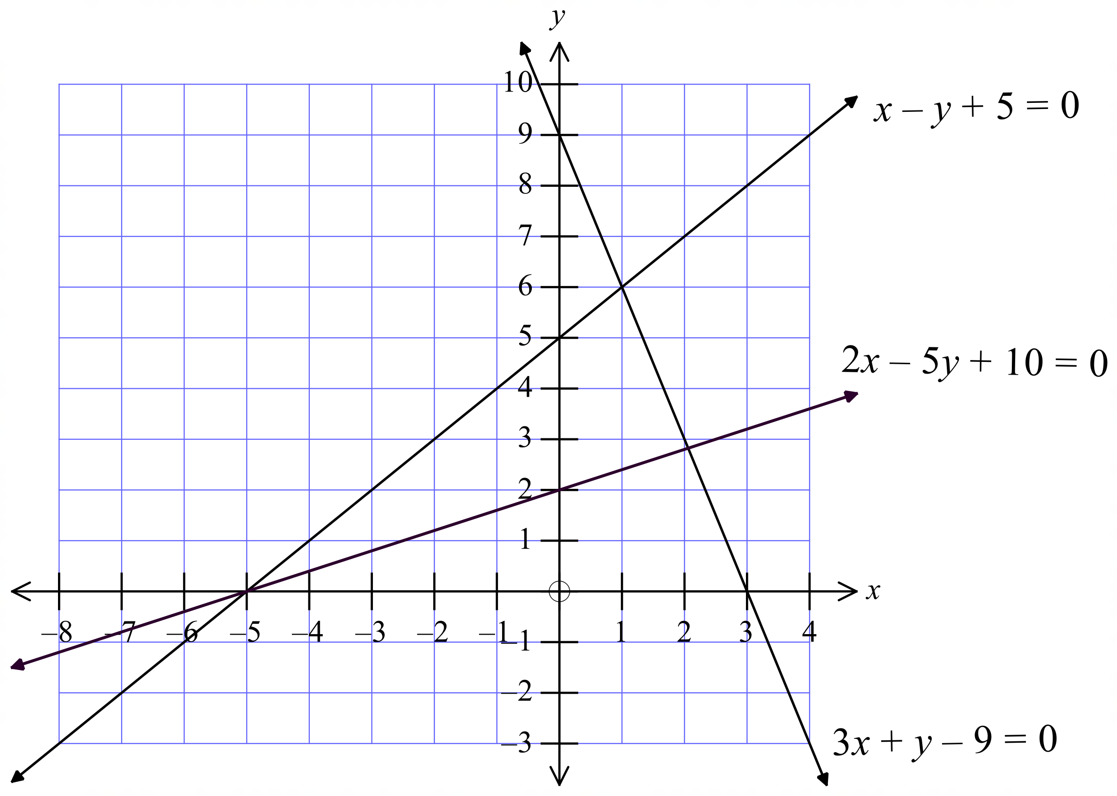

Solve 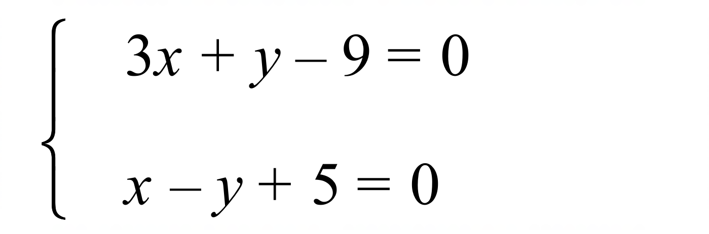

A. 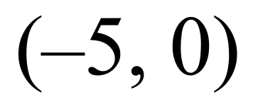 B. 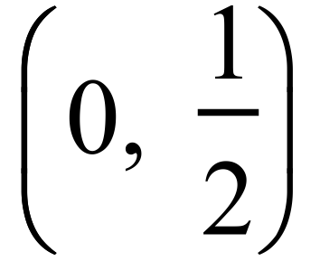 C. (2, 3) D. (1, 6)
Solve 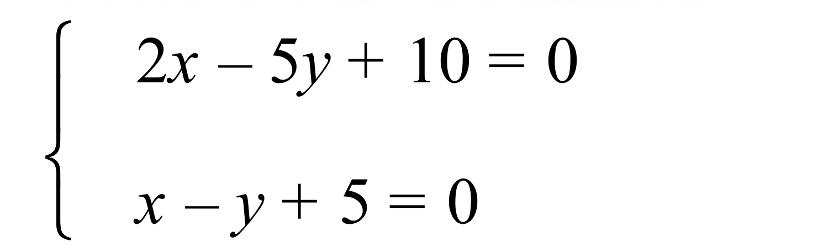

A. B. C. (2, 3) D. (1, 6)
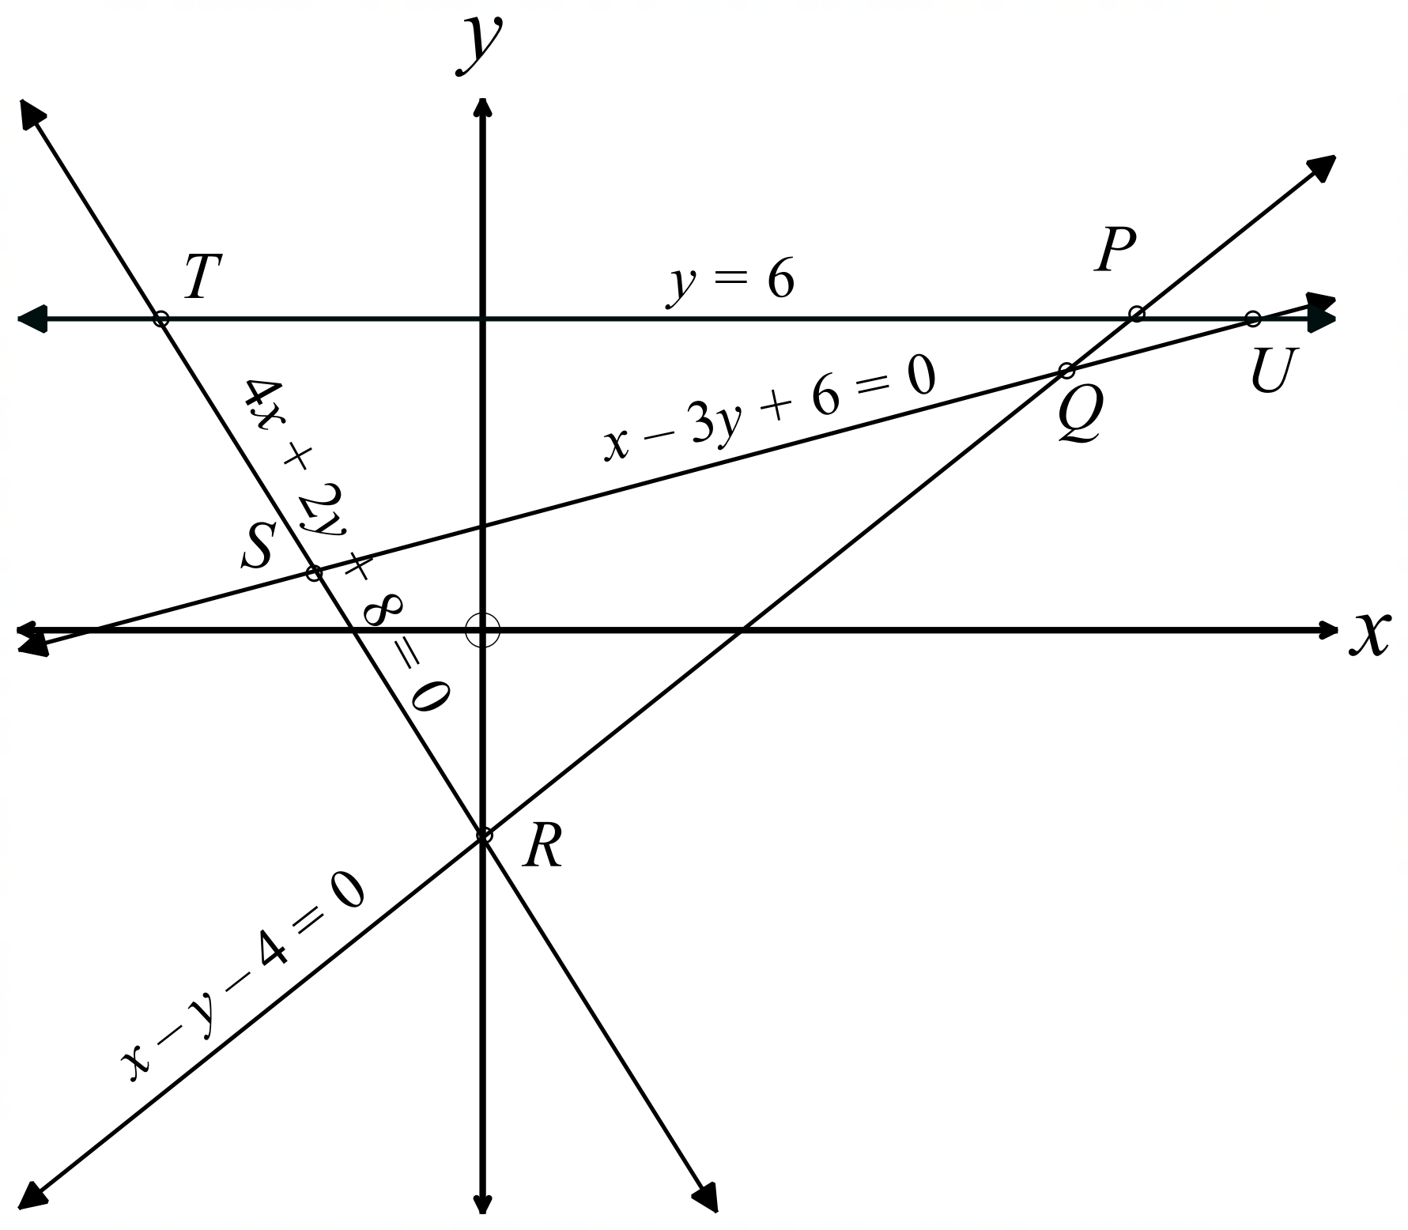Questions 10 – 12 refer to the following.
The number plane shows the lines
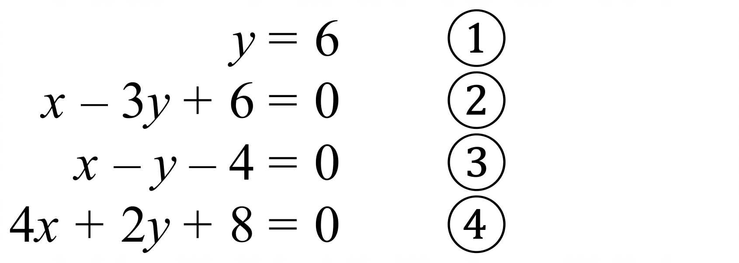

The points of intersection of these lines are labelled on the graph.

The point S is the solution to which pair of simultaneous equations?

A.  

B. 

C. 

D. 

Which point is the simultaneous solution to equations 

A. Point P B. Point Q C. Point T D. Point U
What are the coordinates of the point T ?

A. (-10, 6) B. (-5, 6) C. (-4, 6) D. (10, 6)

School Name
Mathematics Test 2017
Year 10 | Simultaneous Equations | Calculator Allowed
Year 10 | Simultaneous Equations | Name___________________
Section 3 Longer Answer Section
Write all working and answers in the spaces provided on this test paper.

 |  | Marks
1. | (a) Solve simultaneously: 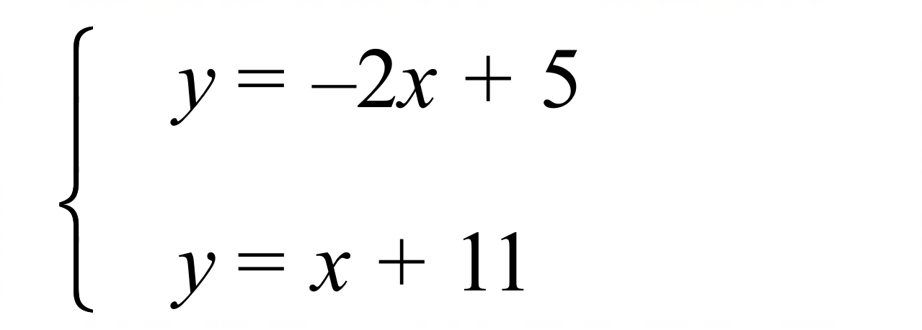  ……………………………………………………………………………………………....  ……………………………………………………………………………………………....  ……………………………………………………………………………………………….  ……………………………………………………………………………………………....  ………………………………………………………………………………………………. | 3
 | (b) Solve simultaneously: 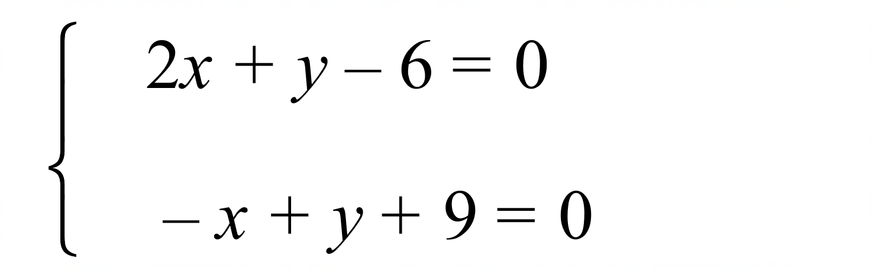  ……………………………………………………………………………………………....  ……………………………………………………………………………………………....  ……………………………………………………………………………………………....  ……………………………………………………………………………………………….  ……………………………………………………………………………………………....  ………………………………………………………………………………………………. | 3
2. | The line 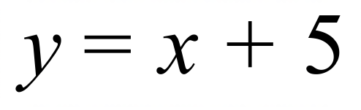 is shown on the graph below.  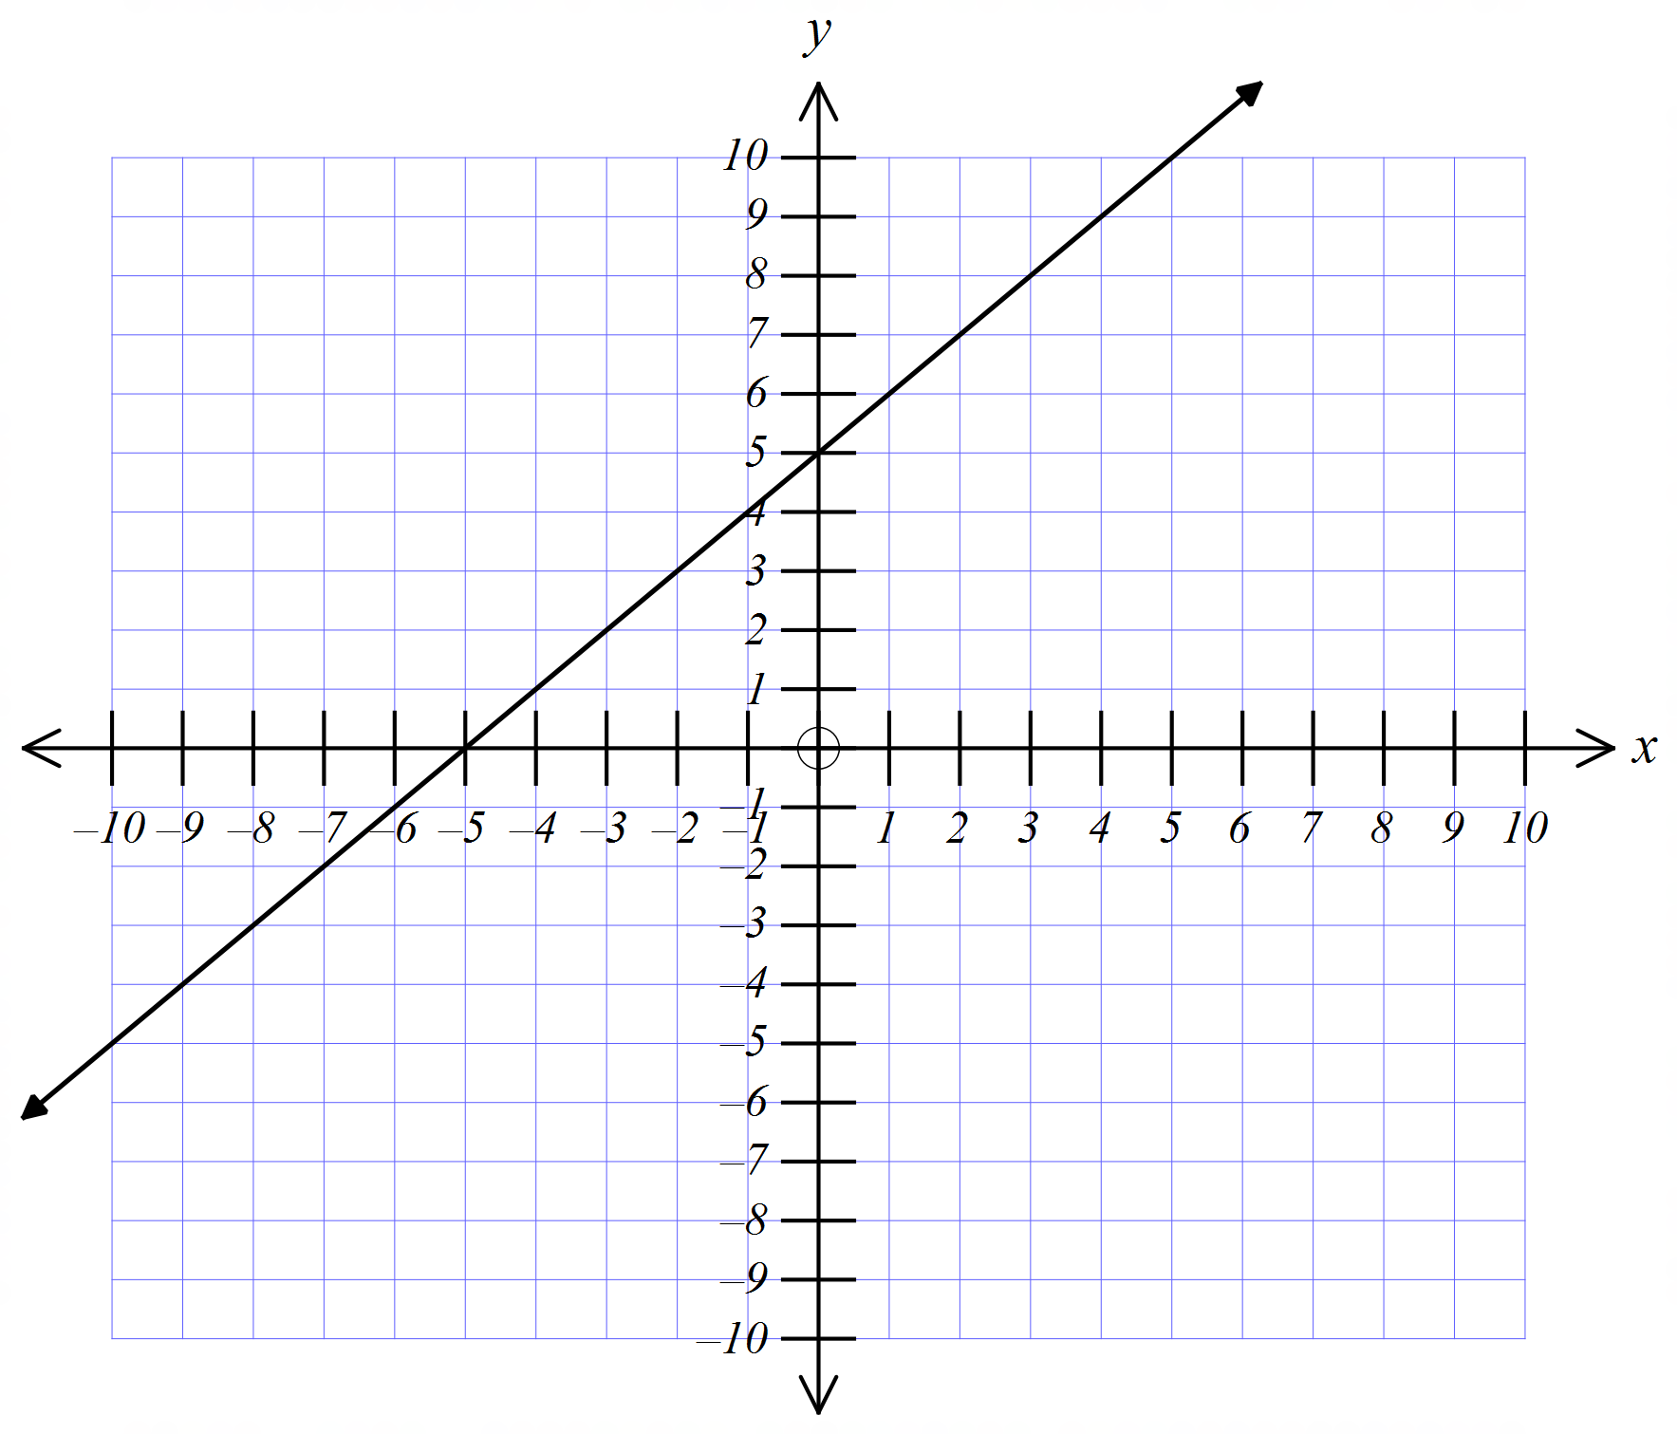
 | (a) Draw the lines | 2
 | (b) Solve 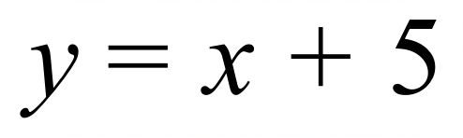 simultaneously with 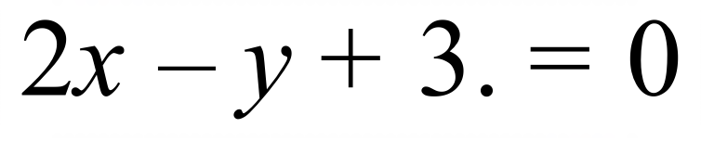  ………………………………………………………………………………………………. | 1
 | (c) Solve 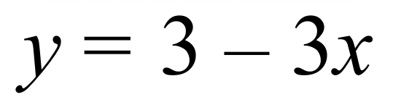 simultaneously with  ………………………………………………………………………………………………. | 1

School Name
Mathematics 2017
Multiple Choice Answer Sheet
Simultaneous Equations
Name _____________________________________________
Completely fill the response oval representing the most correct answer.
1. A B C D
2. A B C D
3. A B C D
4. A B C D
5. A B C D
6. A B C D
7. A B C D
8. A B C D
9. A B C D
10. A B C D
11. A B C D
12. A B C D

School Name
Mathematics Test 2017
Year 10 | Simultaneous Equations | Non Calculator Section
ANSWERS

Question | Working and Answer
 | 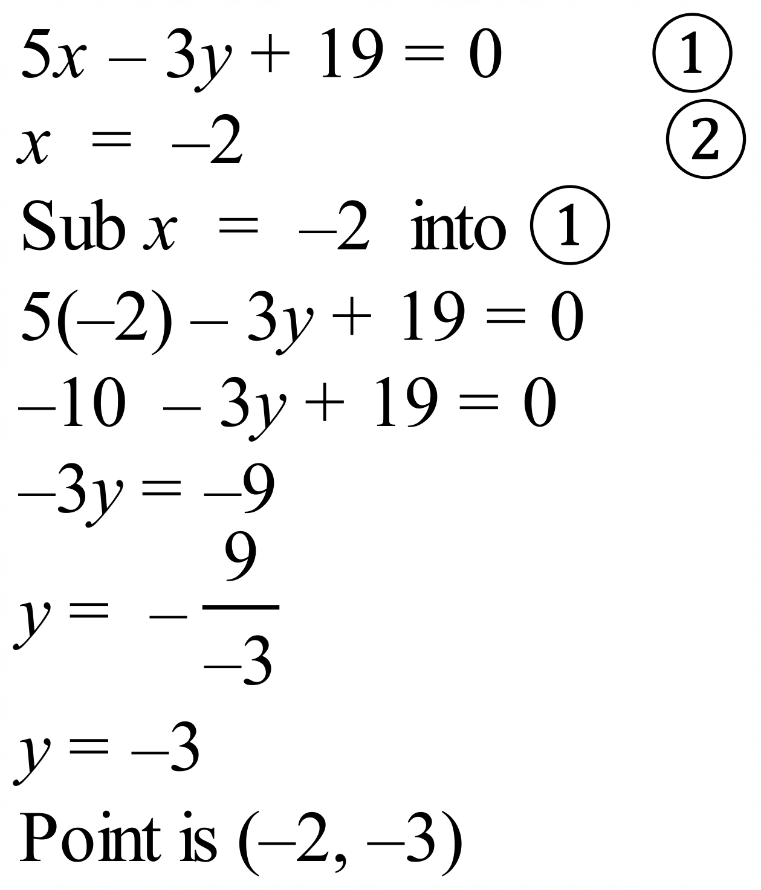
 | 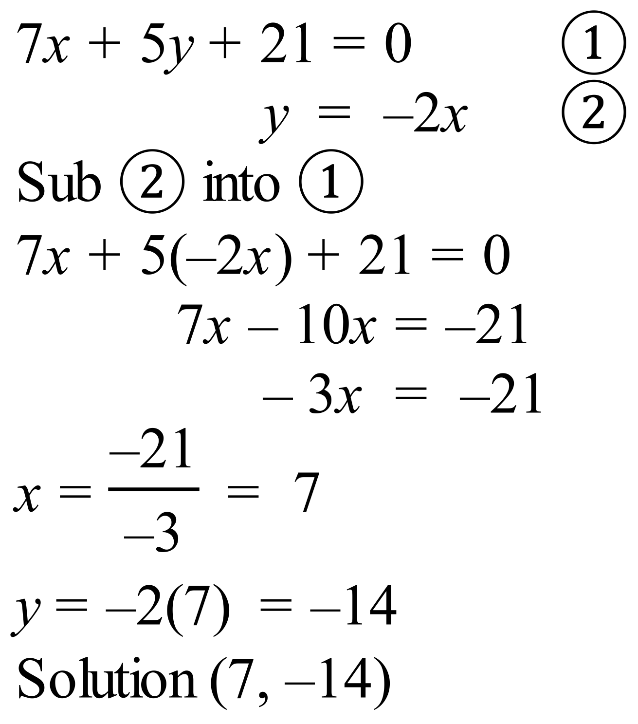
 | 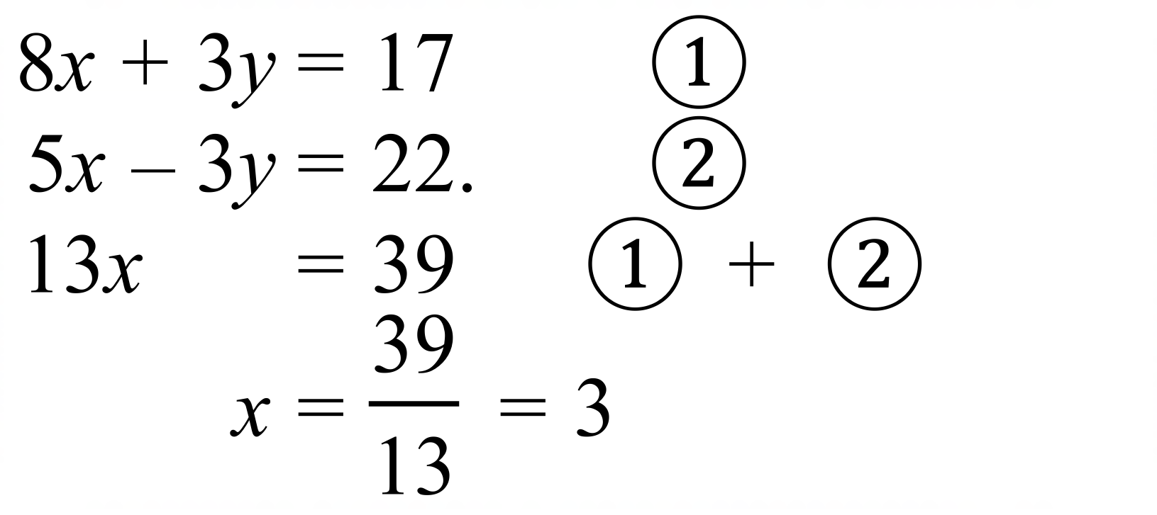
 | 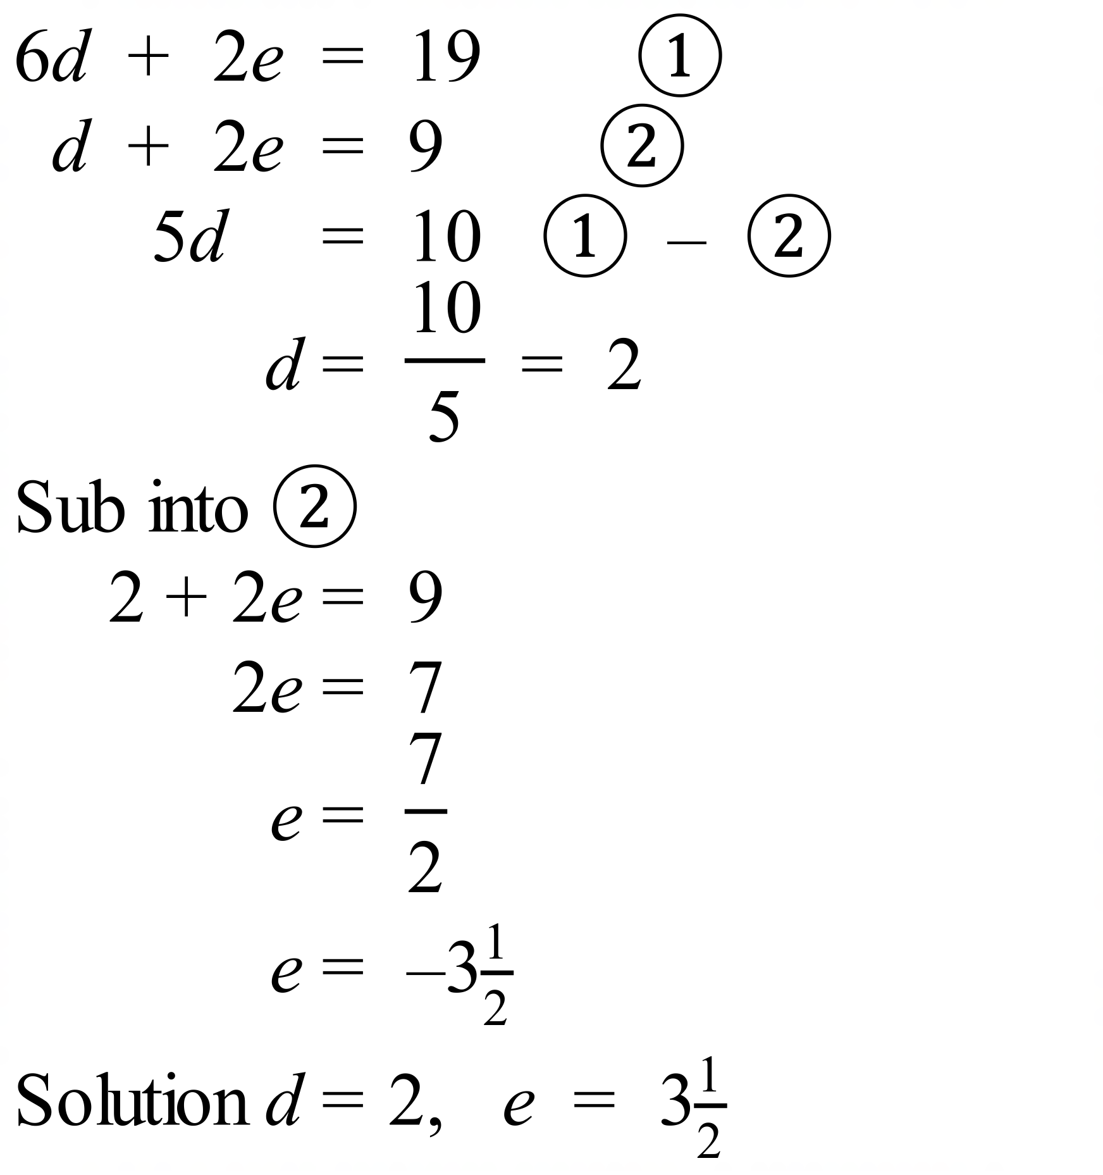
 | 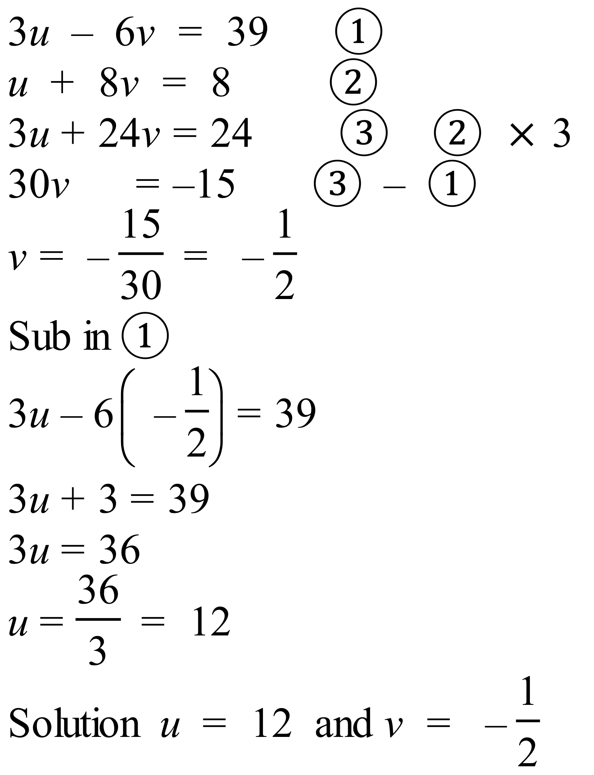
 | 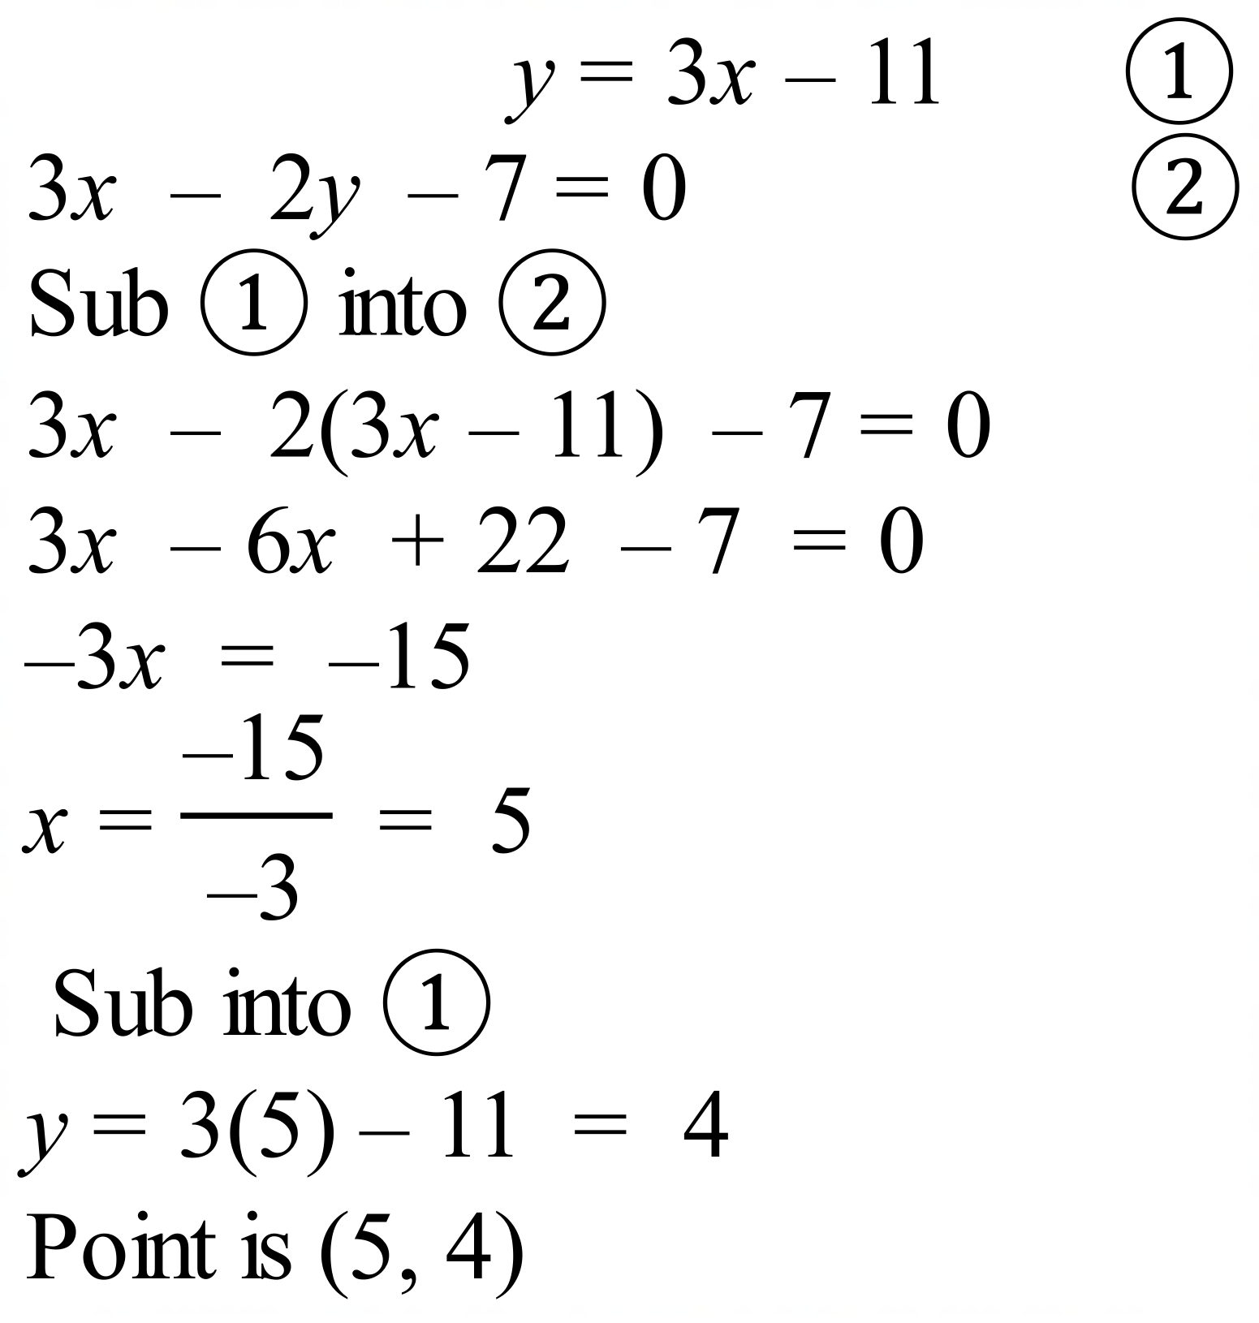
 | 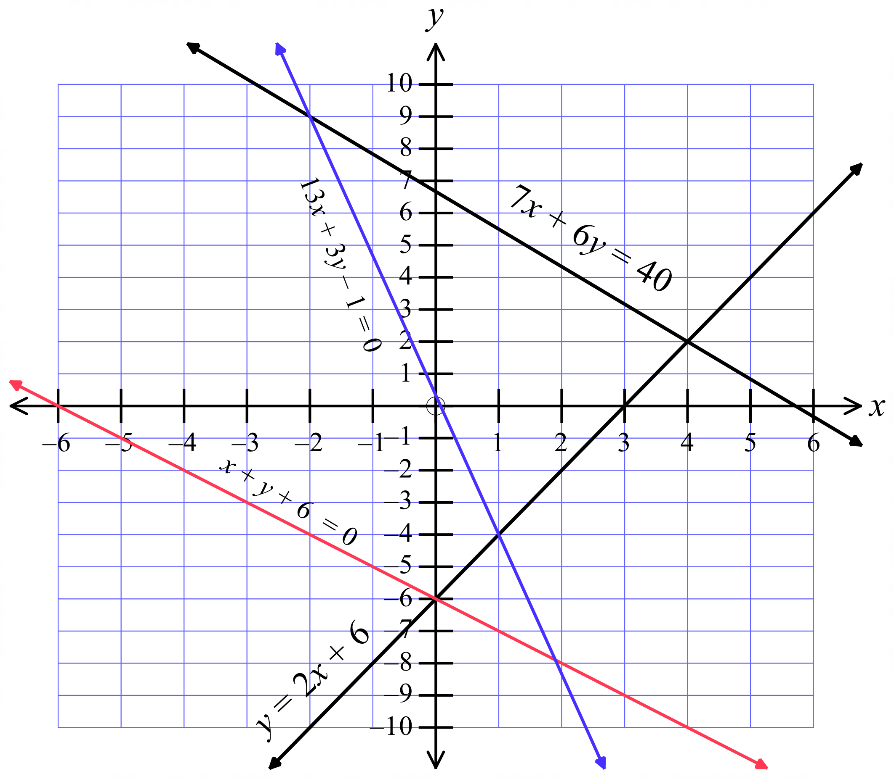
 | 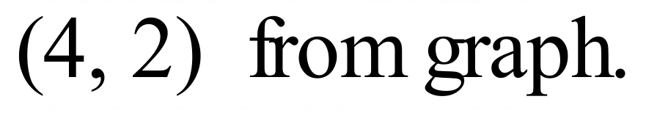
 | See graph above
 | See graph above
 | 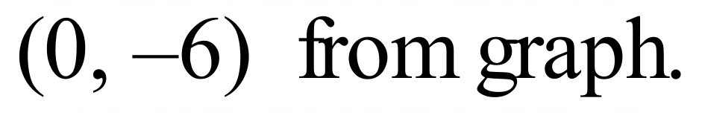
 | 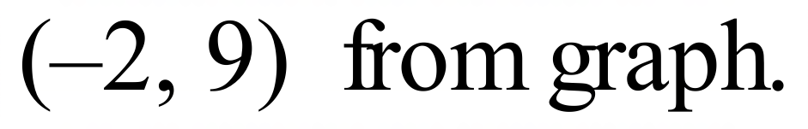
 | 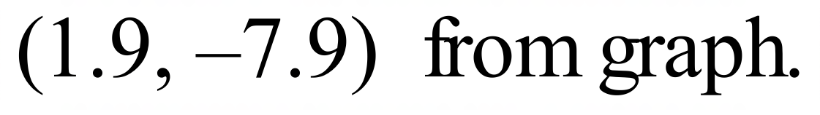

School Name
Mathematics Test 2017
Year 10 | Simultaneous Equations | Calculator Allowed  Multiple Choice  Section

ANSWERS

Question | Working | M C Answer
 | 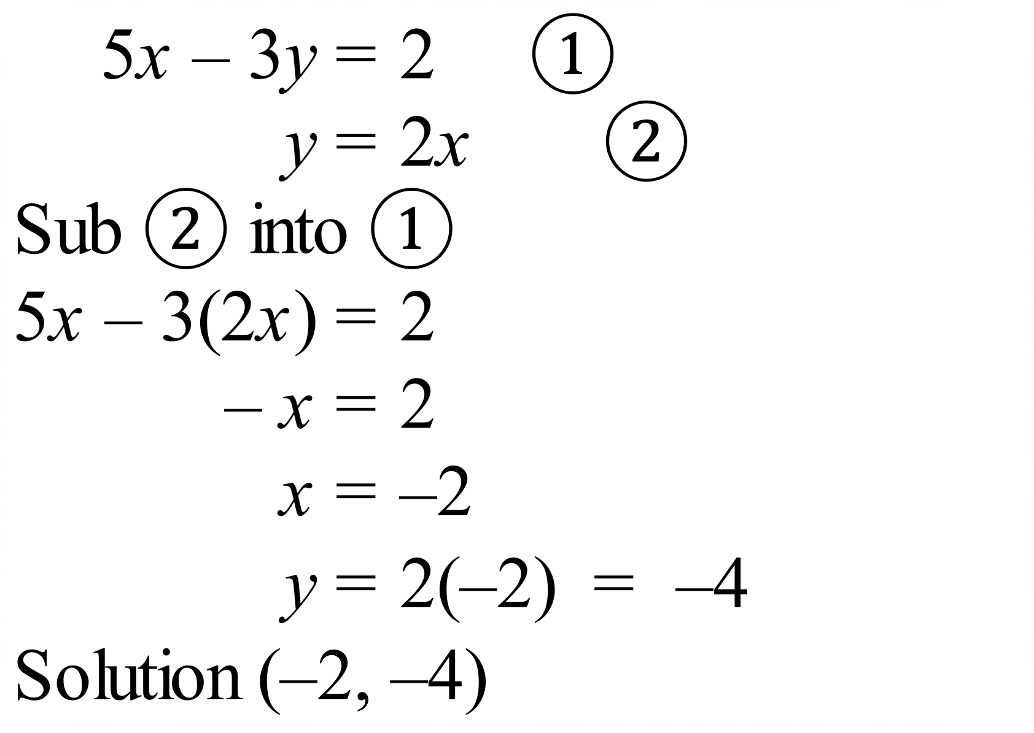 | B
 | 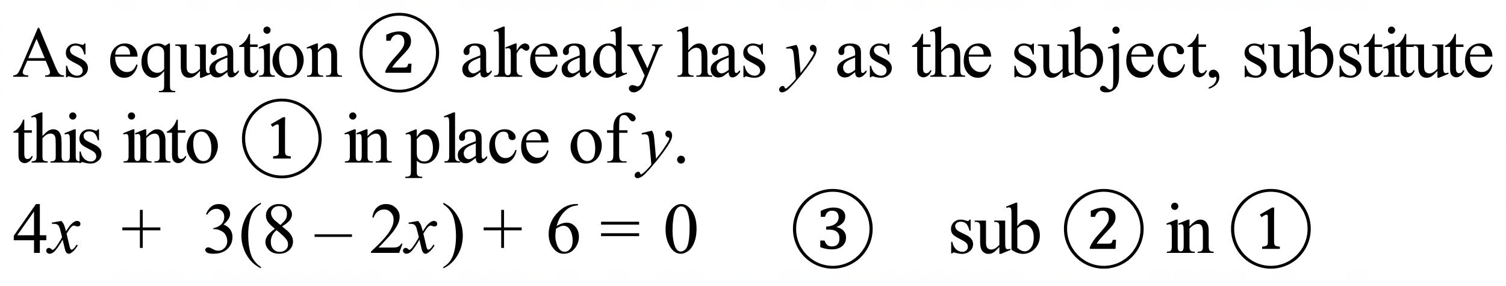 | C
 | 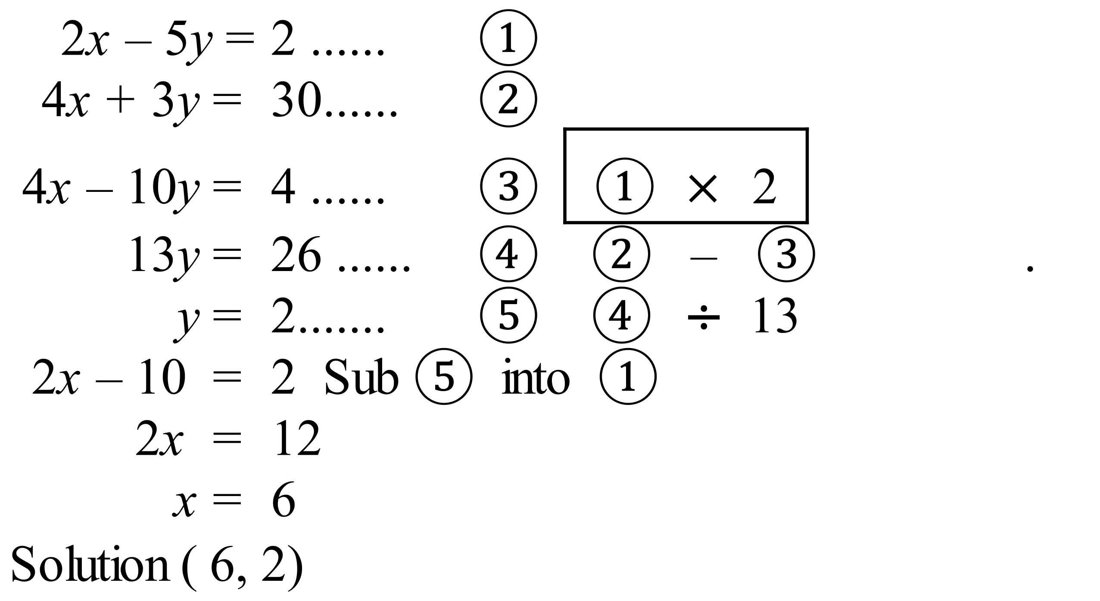 | A
 | See above | D
 | 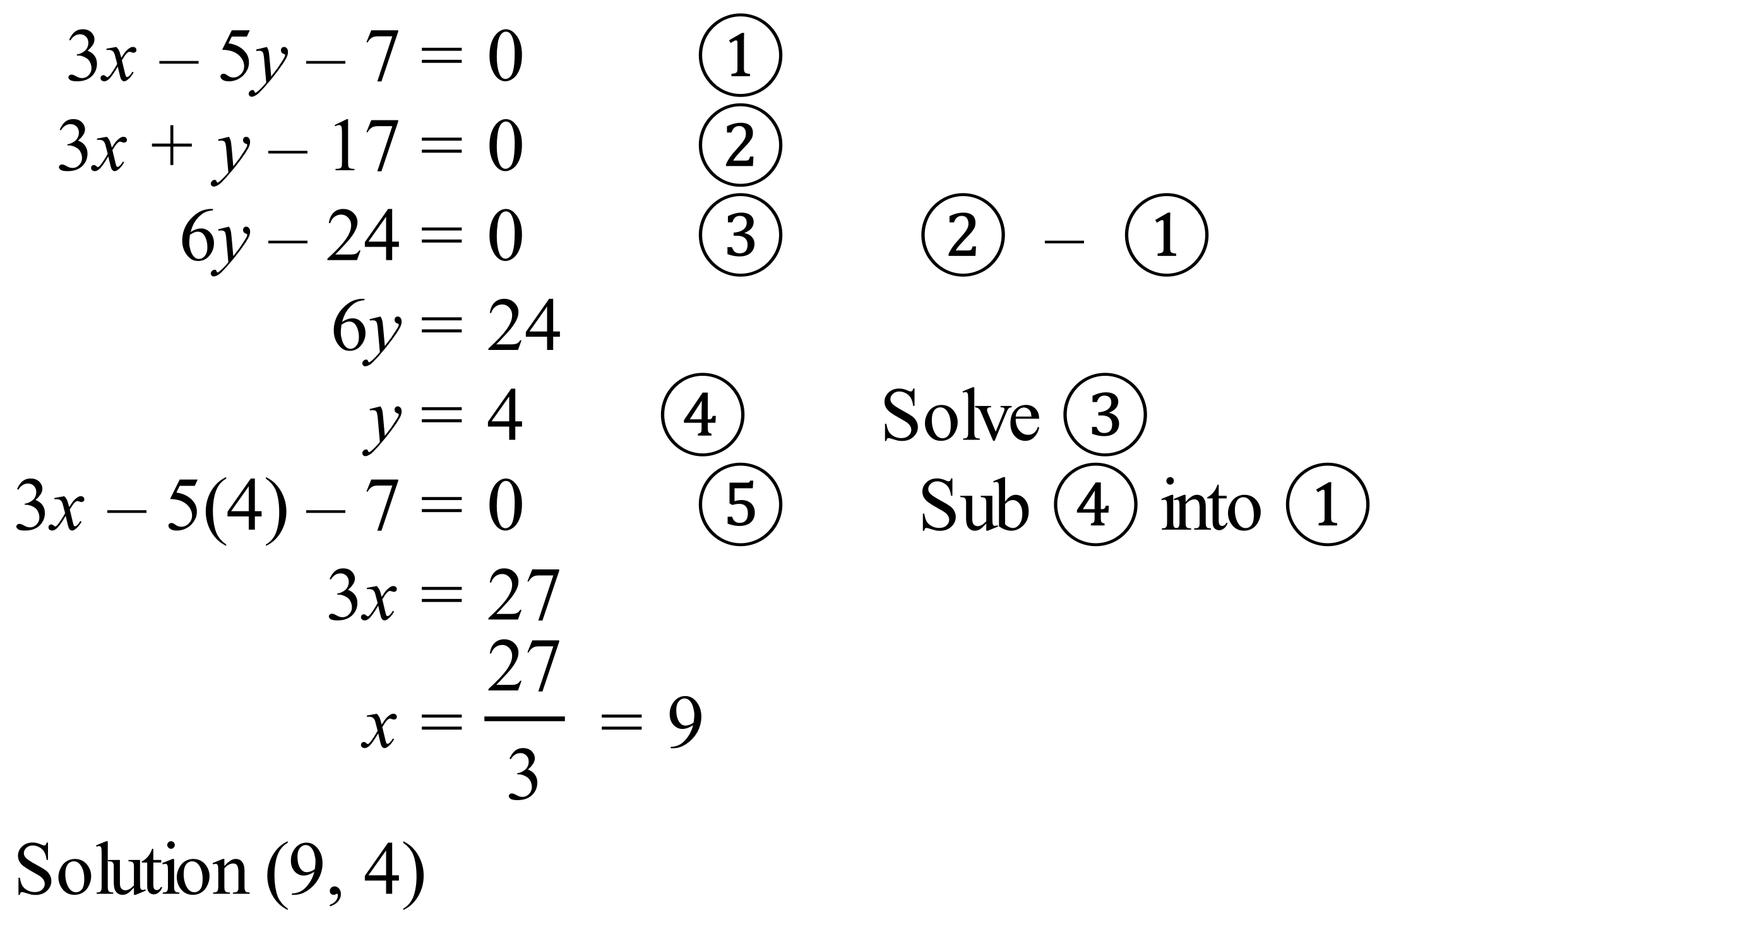 | C
 | 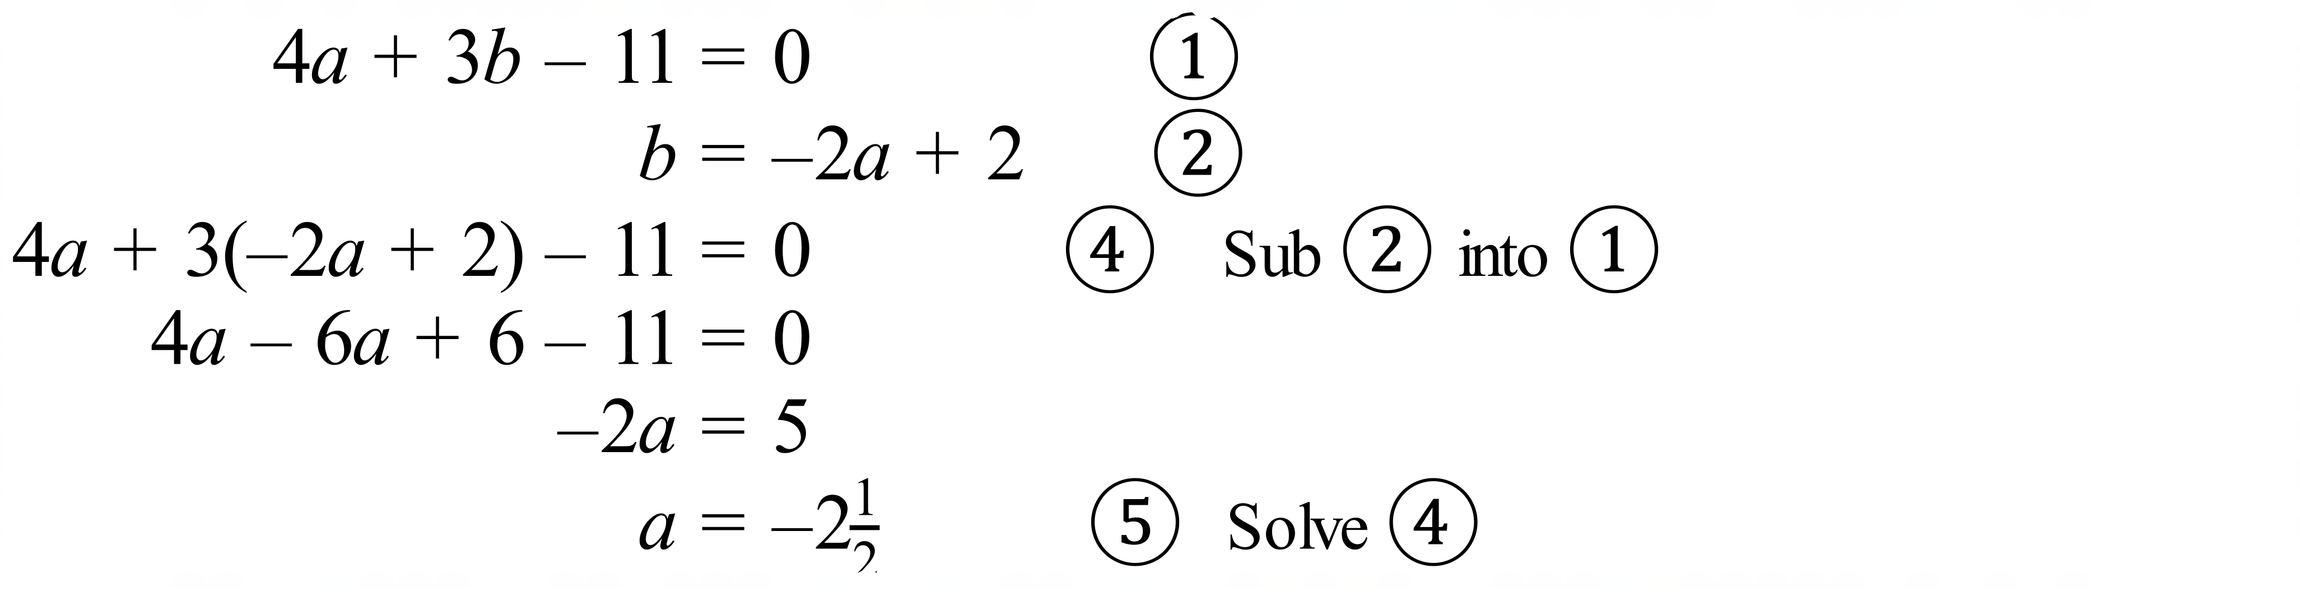 | B
 | 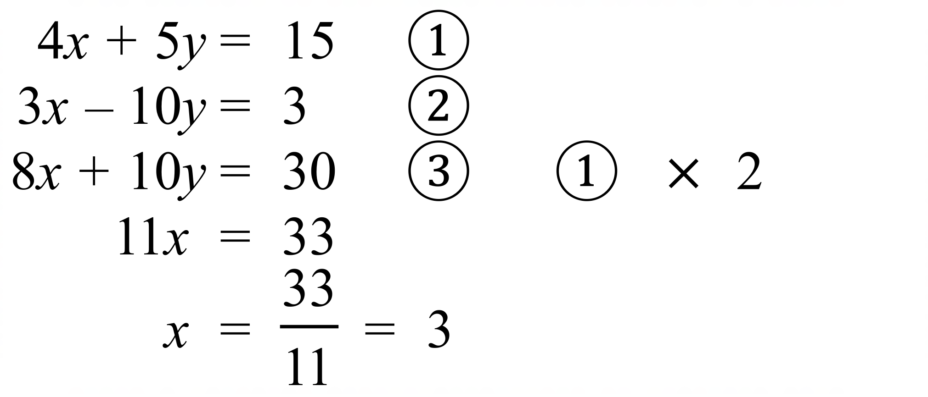 | D
 | (1, 6) | D
 | (-5, 0) | A
 |  | C
 |  | A
 | 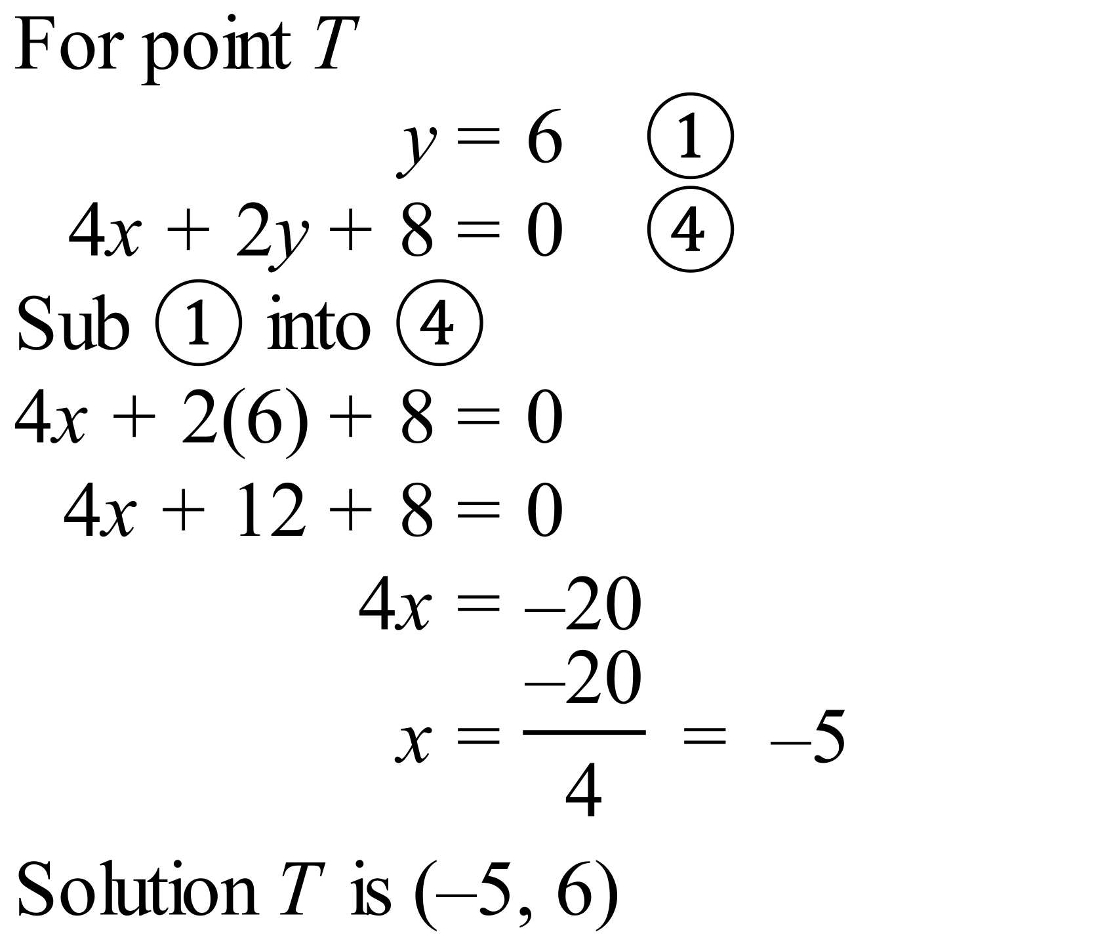 | B

School Name
Mathematics 2017
Multiple Choice Answer Sheet
Simultaneous Equations
Name _____________________________________________
Completely fill the response oval representing the most correct answer.
1. A B C D
2. A B C D
3. A B C D
4. A B C D
5. A B C D
6. A B C D
7. A B C D
8. A B C D
9. A B C D
10. A B C D
11. A B C D
12. A B C D

School Name
Mathematics Test 2017
Year 10 | Simultaneous Equations | Calculator Allowed  Longer Answer  Section
ANSWERS
Question | Working and Answer | Marks
1. | (a) 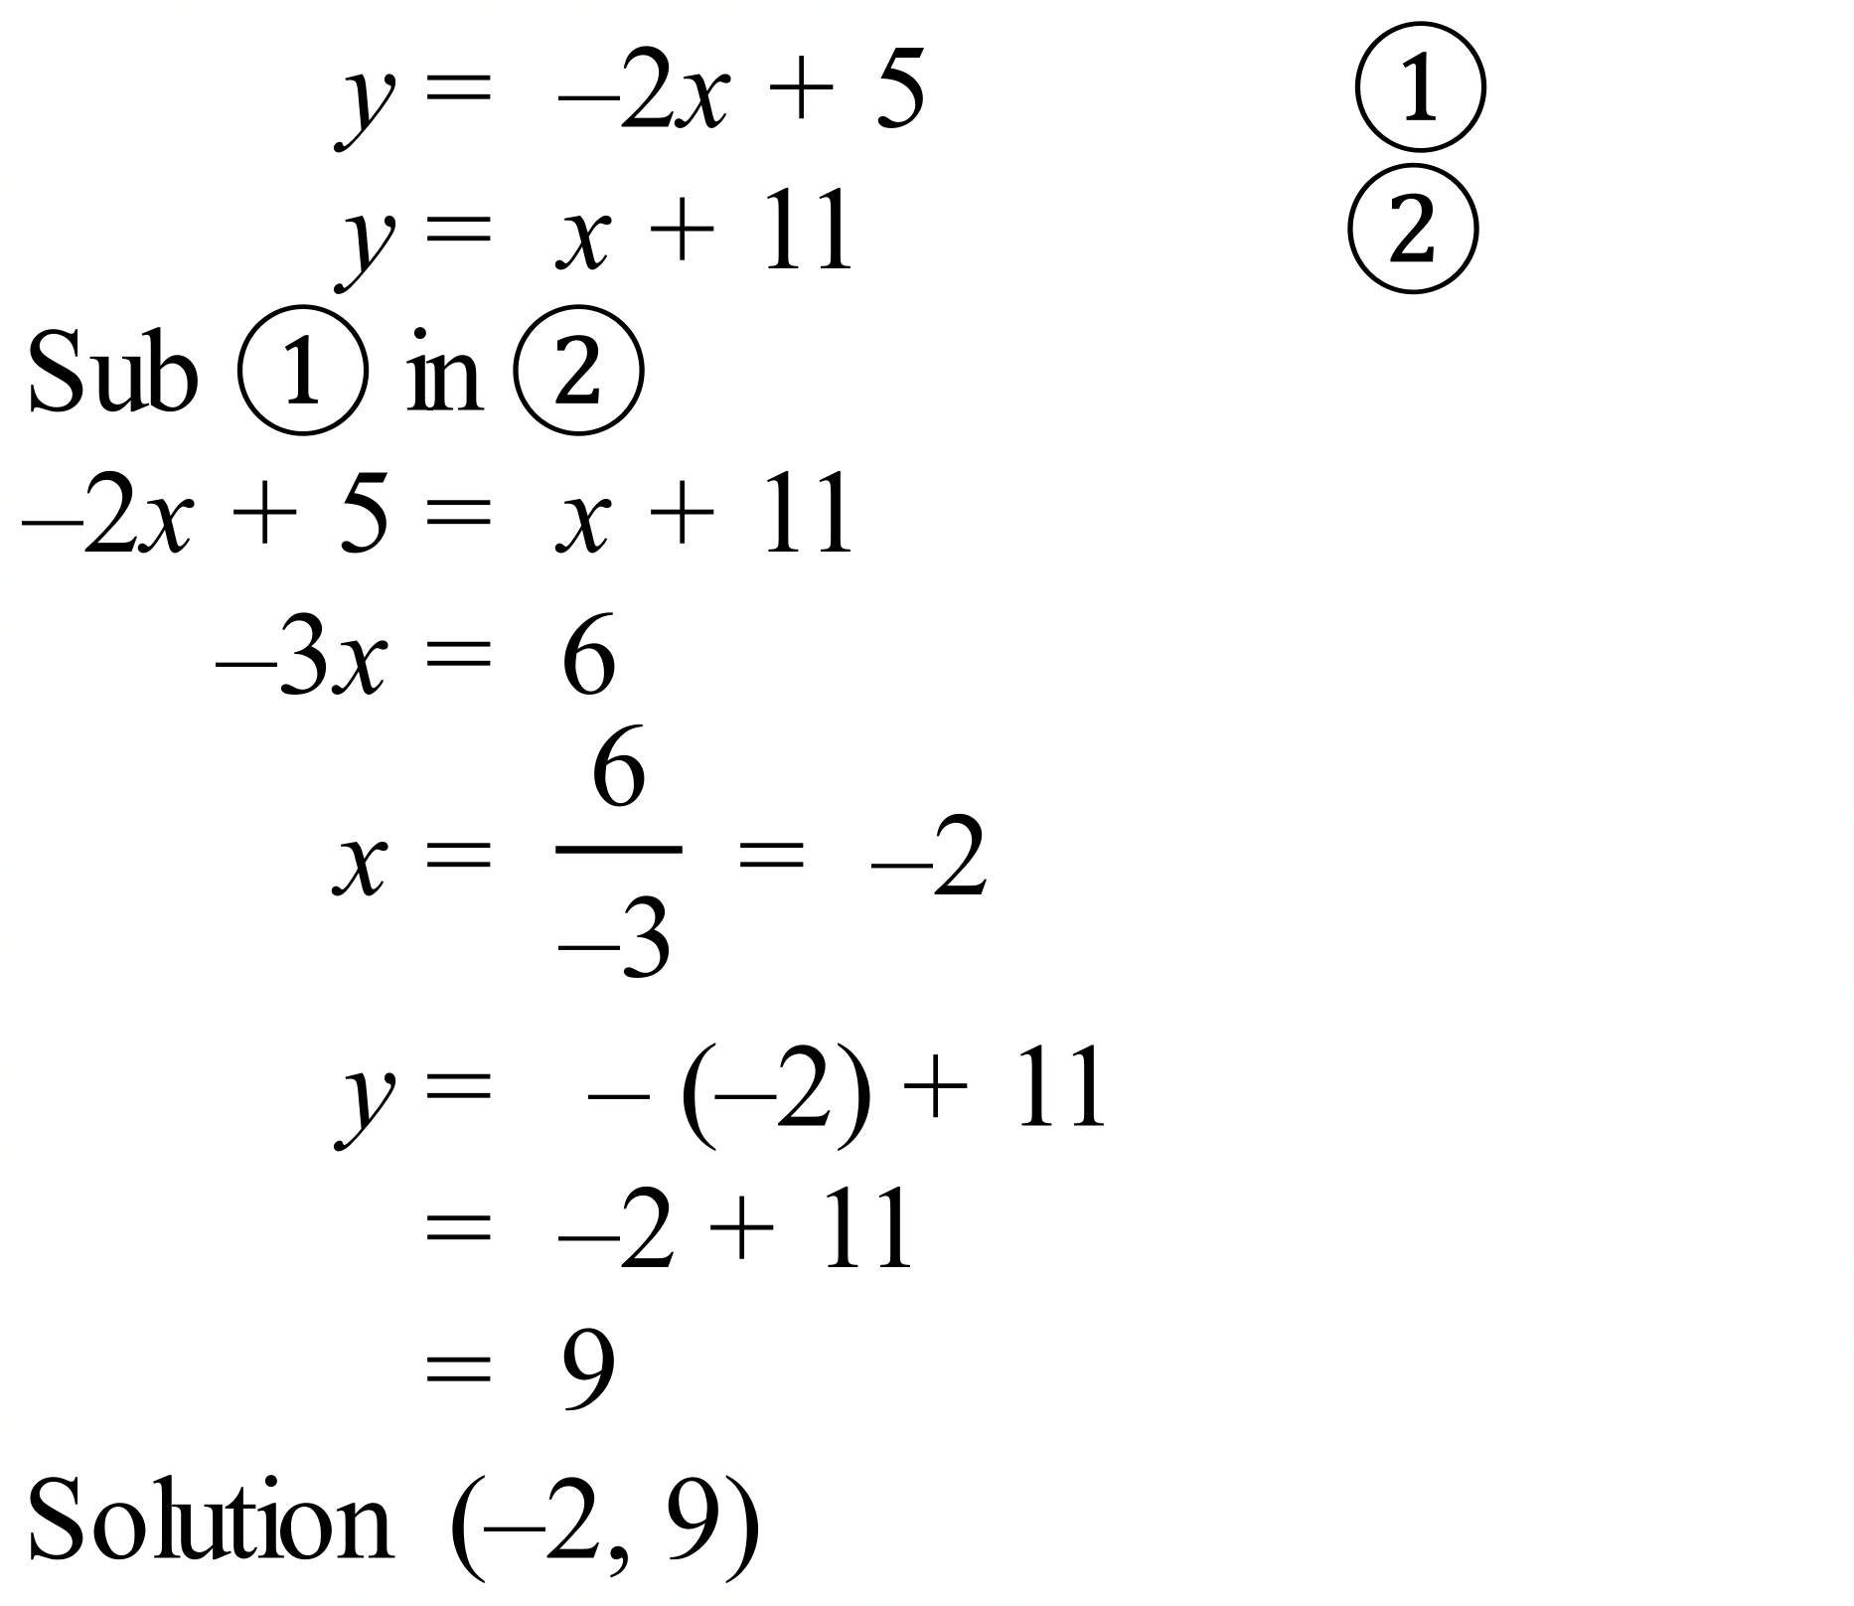 | 3 marks for correct answer with working.  2 marks for almost complete partial answer, or incorrect answer with only minor errors  1 mark for some basic working on the right course
 | (b) 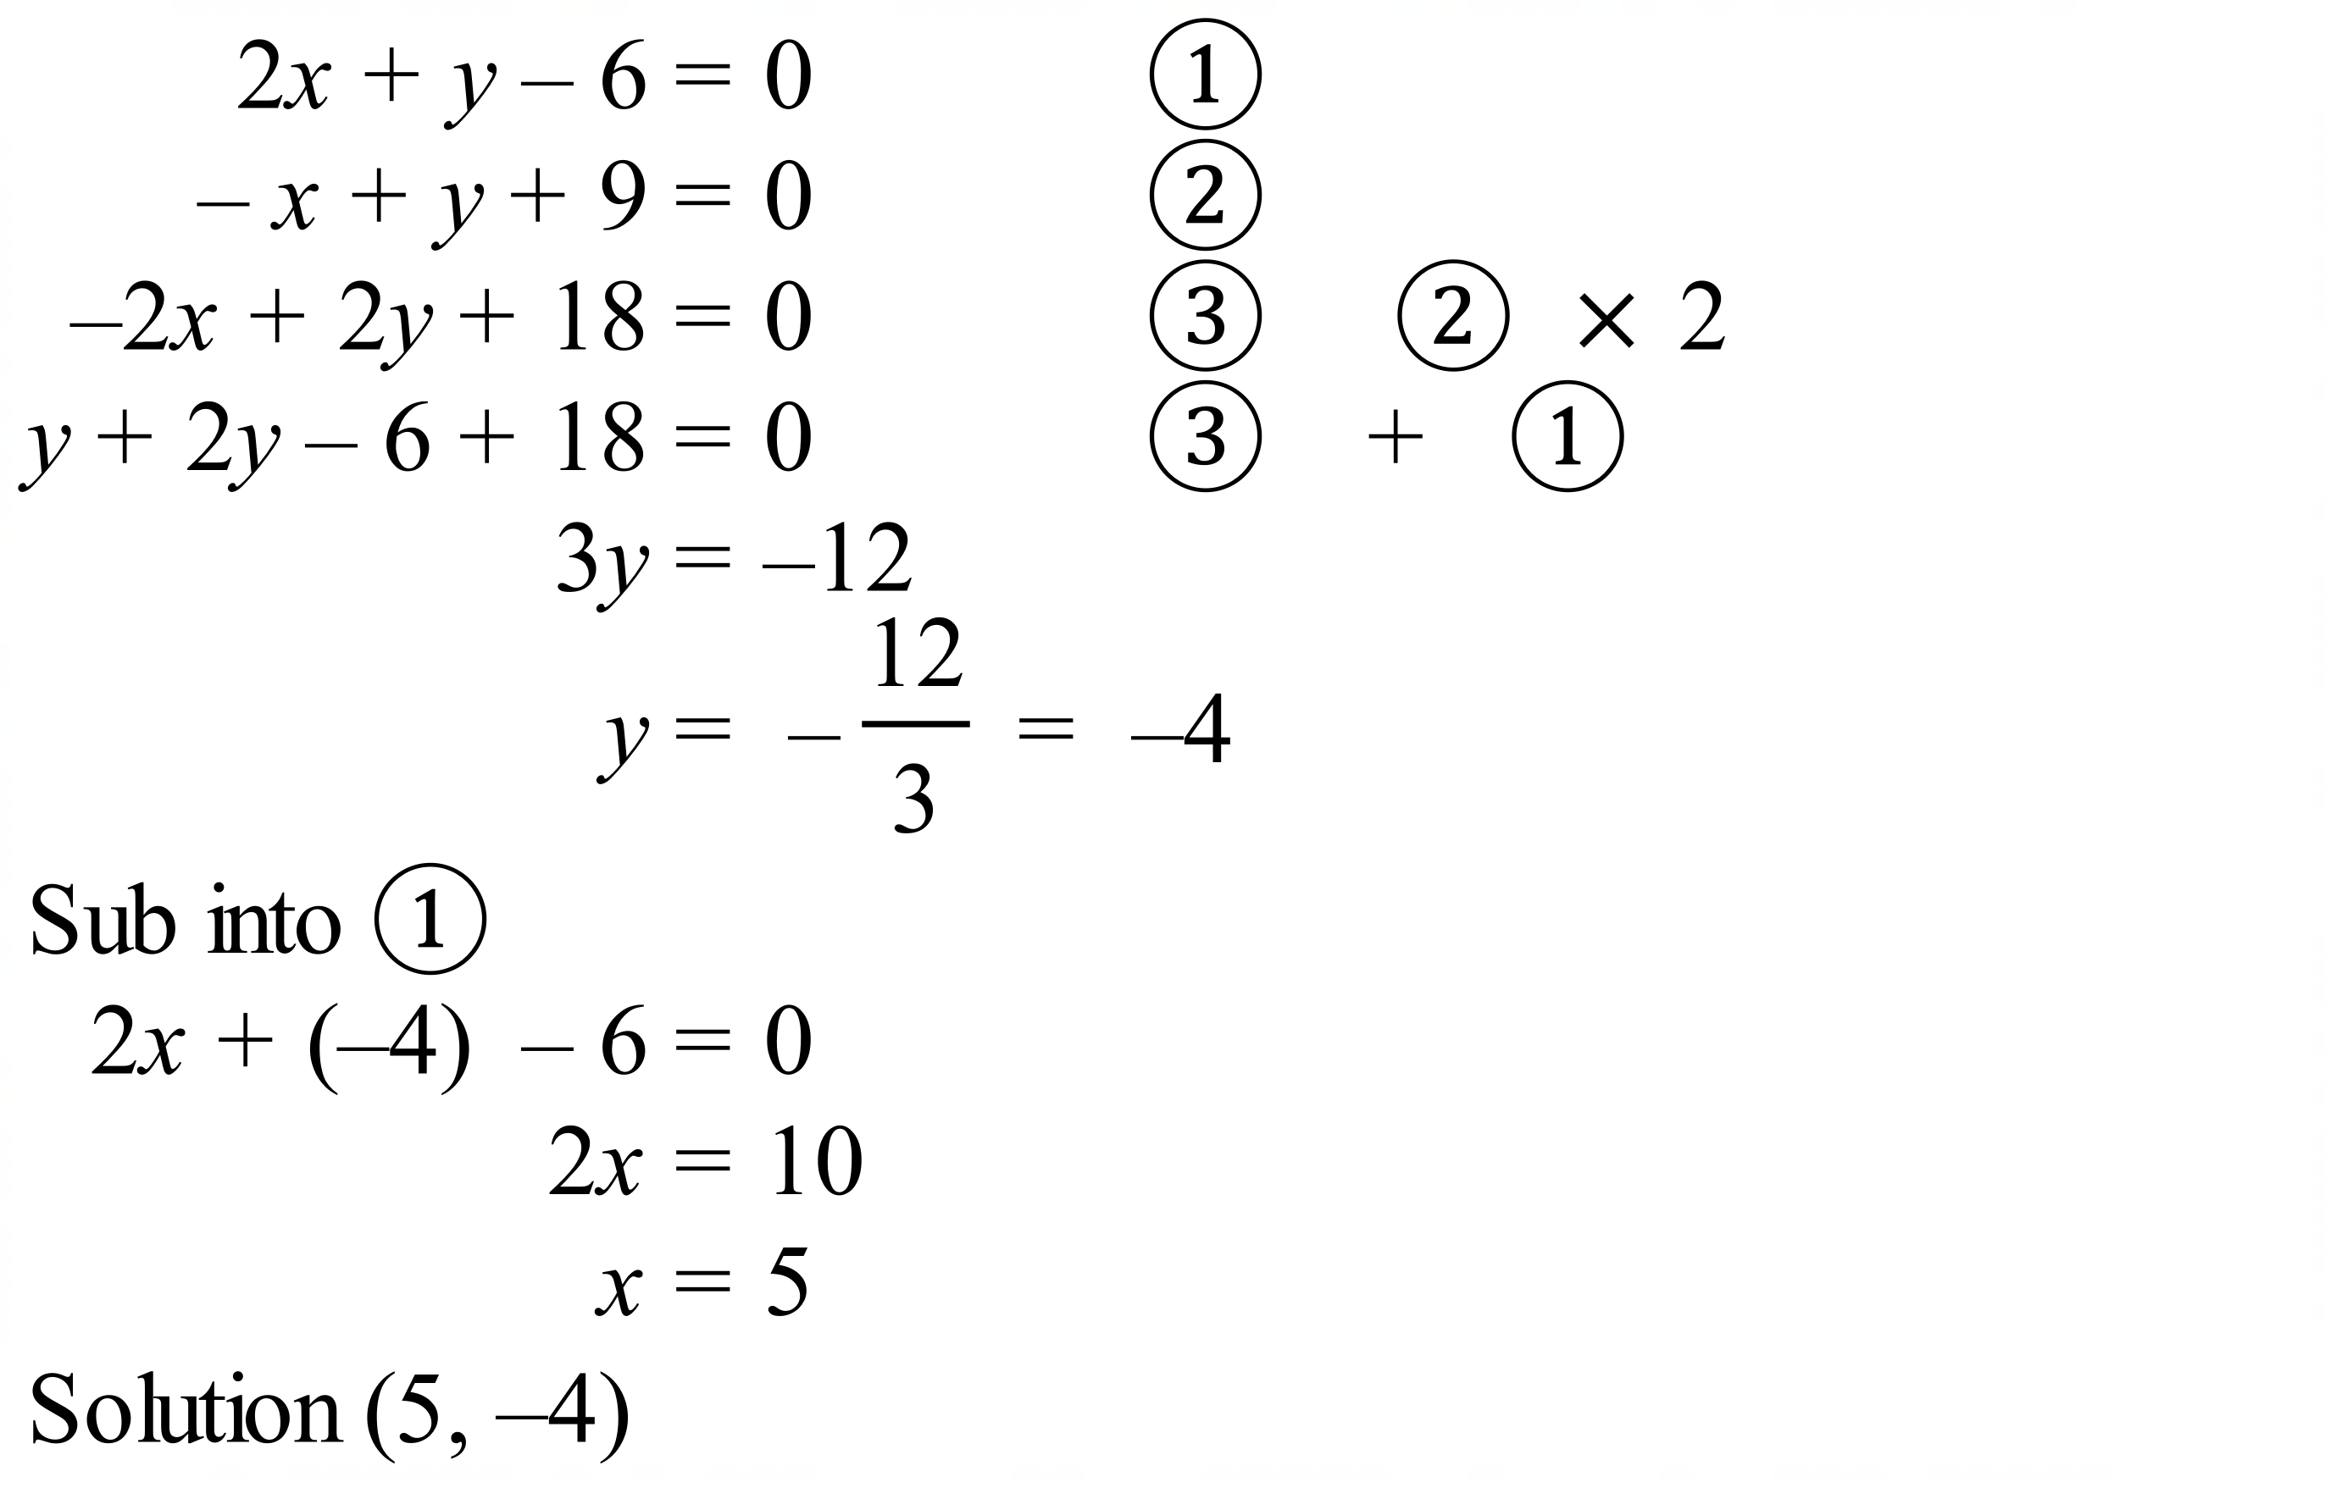 | 3 marks for correct answer with working.  2 marks for almost complete partial answer, or incorrect answer with only minor errors  1 mark for some basic working on the right course
2. | (a)  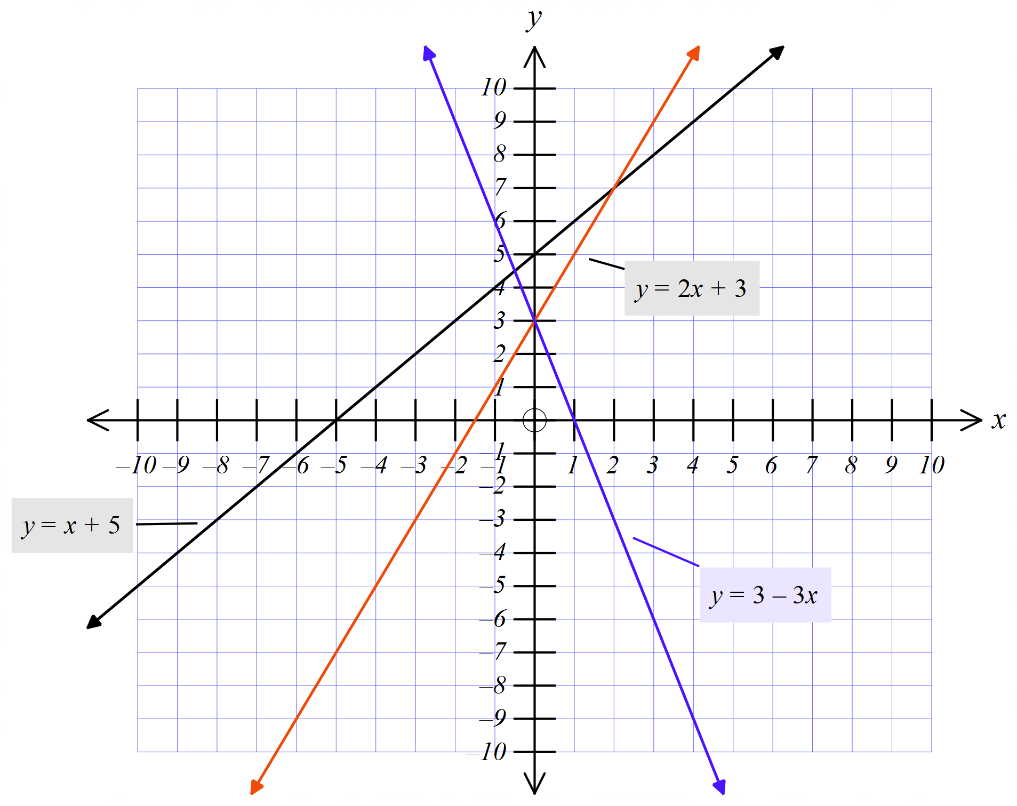 | 1 mark for each of the red and blue lines on this graph
 | (b) (2, 7) | 1 mark for correct point read from graph
 | (c) (0, 3) | 1 mark for correct point read from graph

